### **Dimensionality Reduction**

**Question 1**: Note: In this question, all columns will be written in their transposed form, as rows, to make the typography simpler. Matrix M has three rows and three columns, and the columns form an orthonormal basis. One of the columns is [2/7,3/7,6/7], and another is [6/7, 2/7, -3/7]. Let the third column be [x,y,z]. Since the length of the vector [x,y,z] must be 1, there is a constraint that x2+y2+z2 = 1. However, there are other constraints, and these other constraints can be used to deduce facts about the ratios among x, y, and z. Compute these ratios.

Ans.

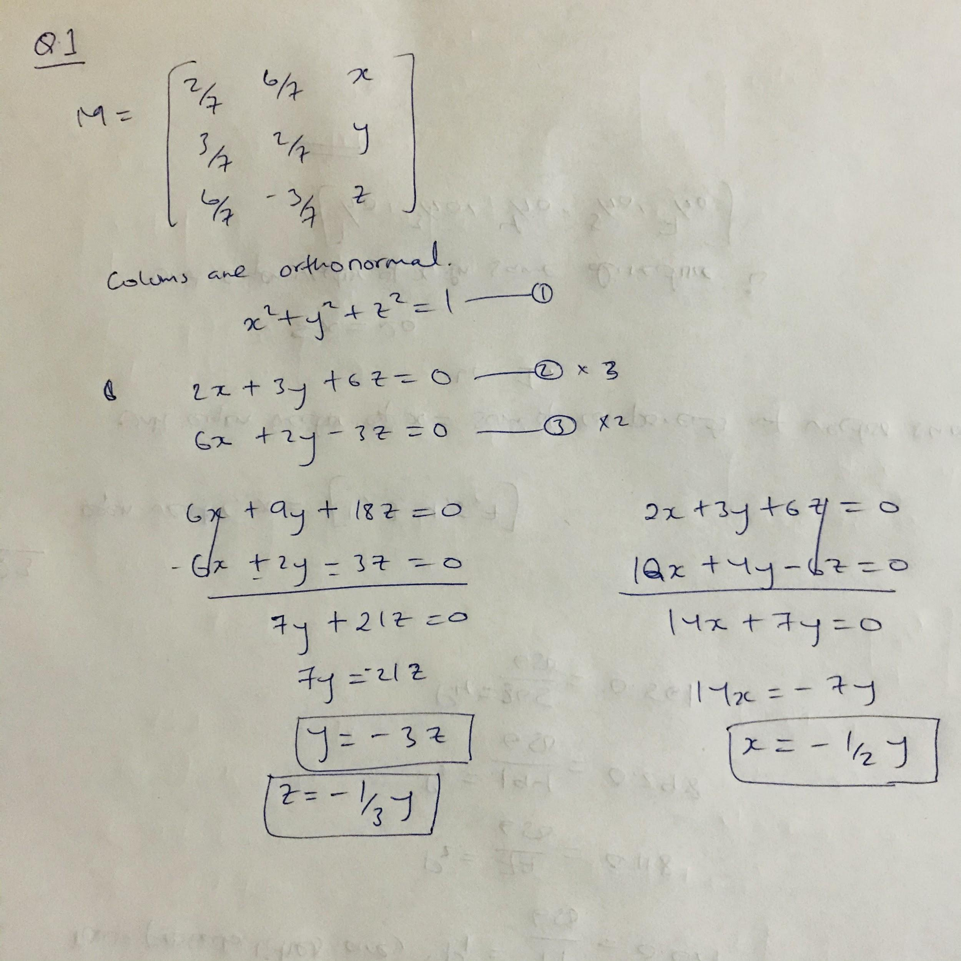

**Question 2**: Find the eigenvalues and eigenvectors of the following matrix:

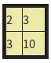

You should assume the first component of an eigenvector is 1. Then, find out One eigenvalue and One eigenvector.

Ans.

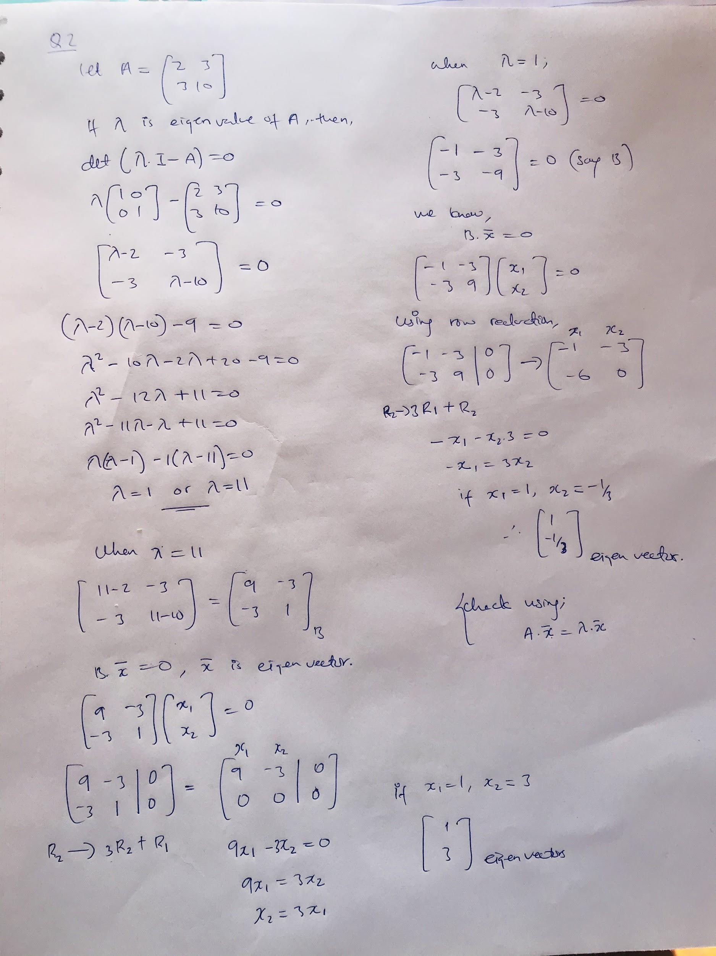

**Question 3**: Suppose [1,3,4,5,7] is an eigenvector of some matrix. What is the unit eigenvector in the same direction? Find out the components of the unit eigenvector.

Ans.

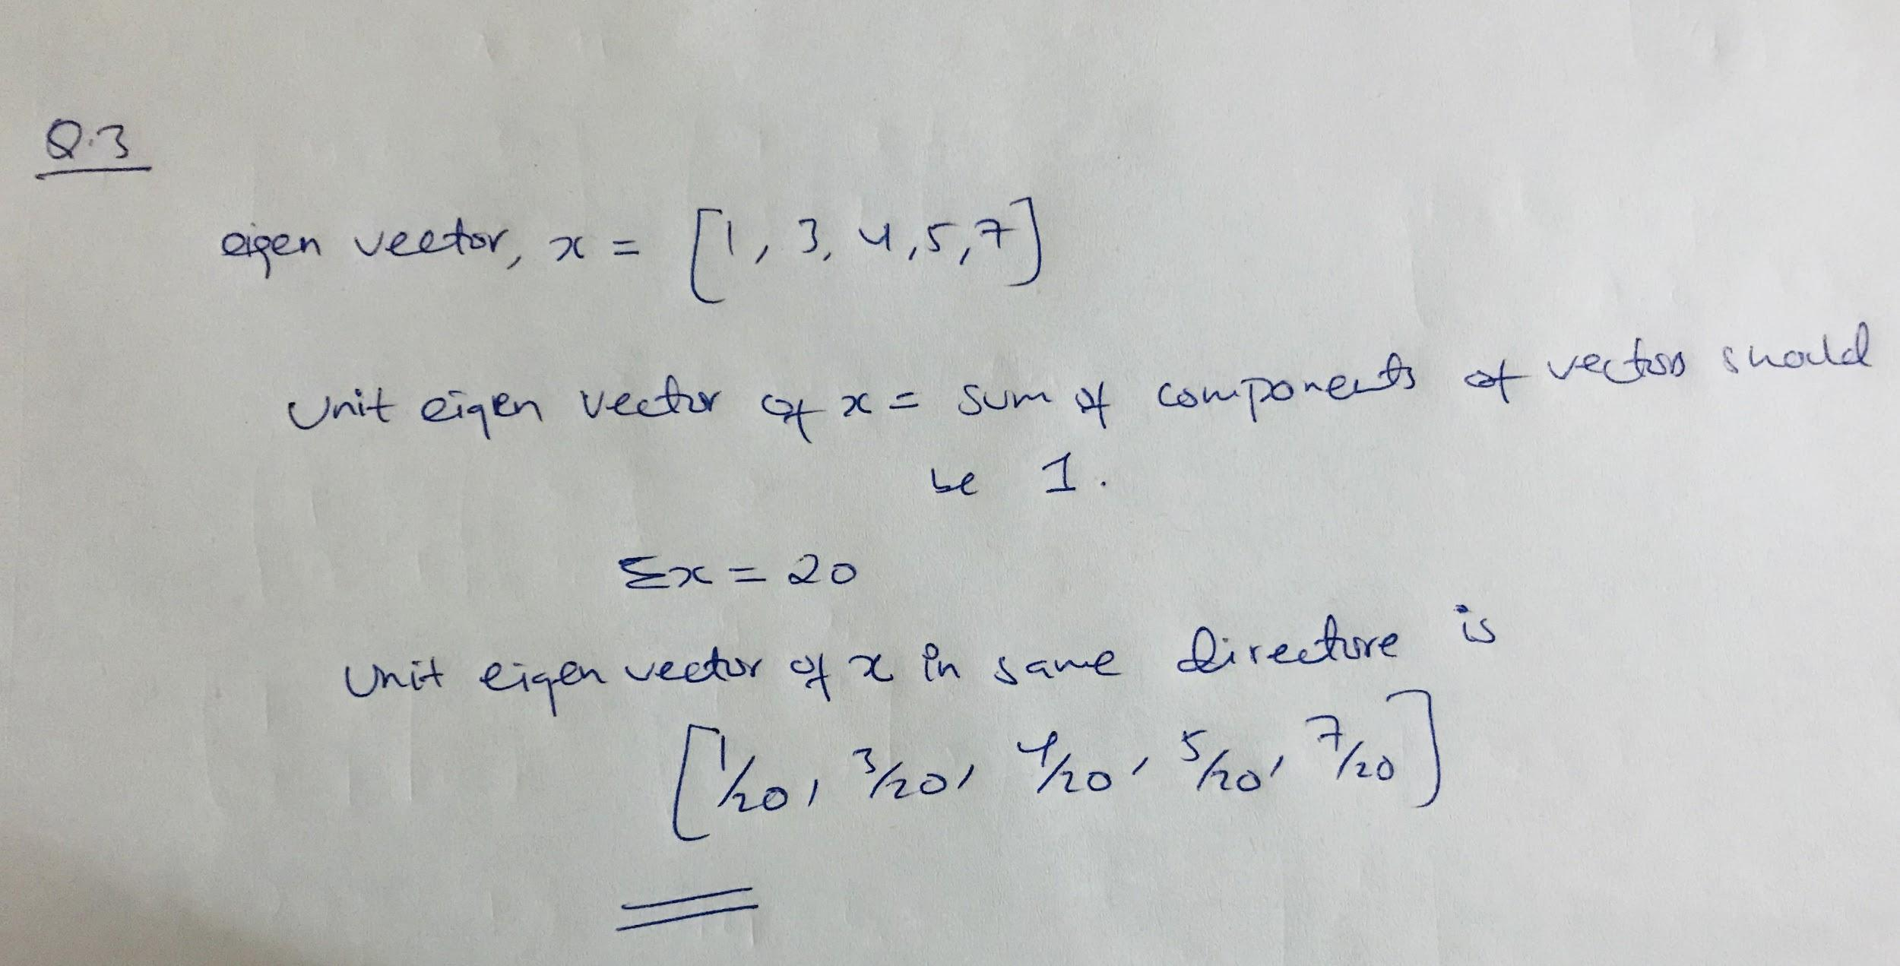

**Question 4**: Suppose we have three points in a two dimensional space: (1,1), (2,2), and (3,4). We want to perform PCA on these points, so we construct a 2-by-2 matrix, call it N, whose eigenvectors are the directions that best represent these three points. Construct the matrix N and identify its elements.

Ans.

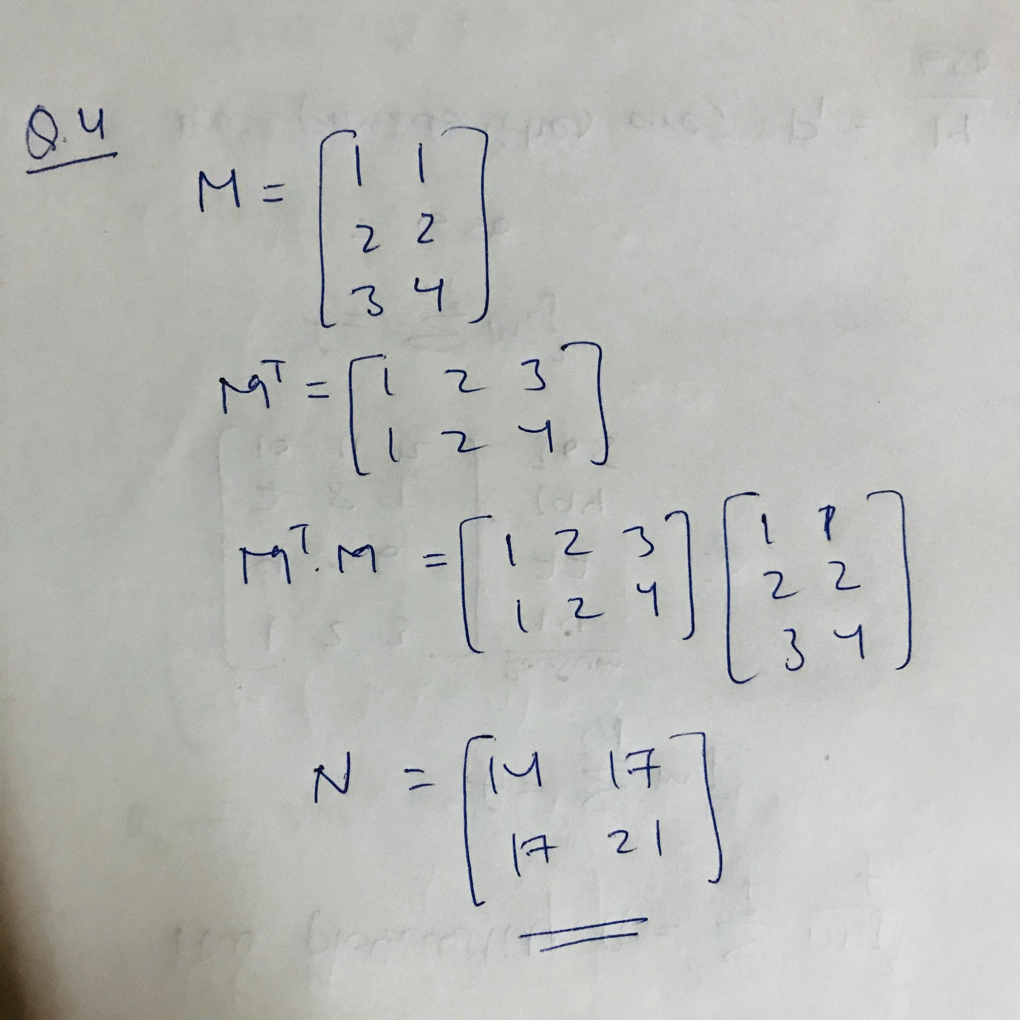

**Question 5**: Consider the diagonal matrix M =

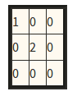

Compute its Moore-Penrose pseudoinverse.

Ans.

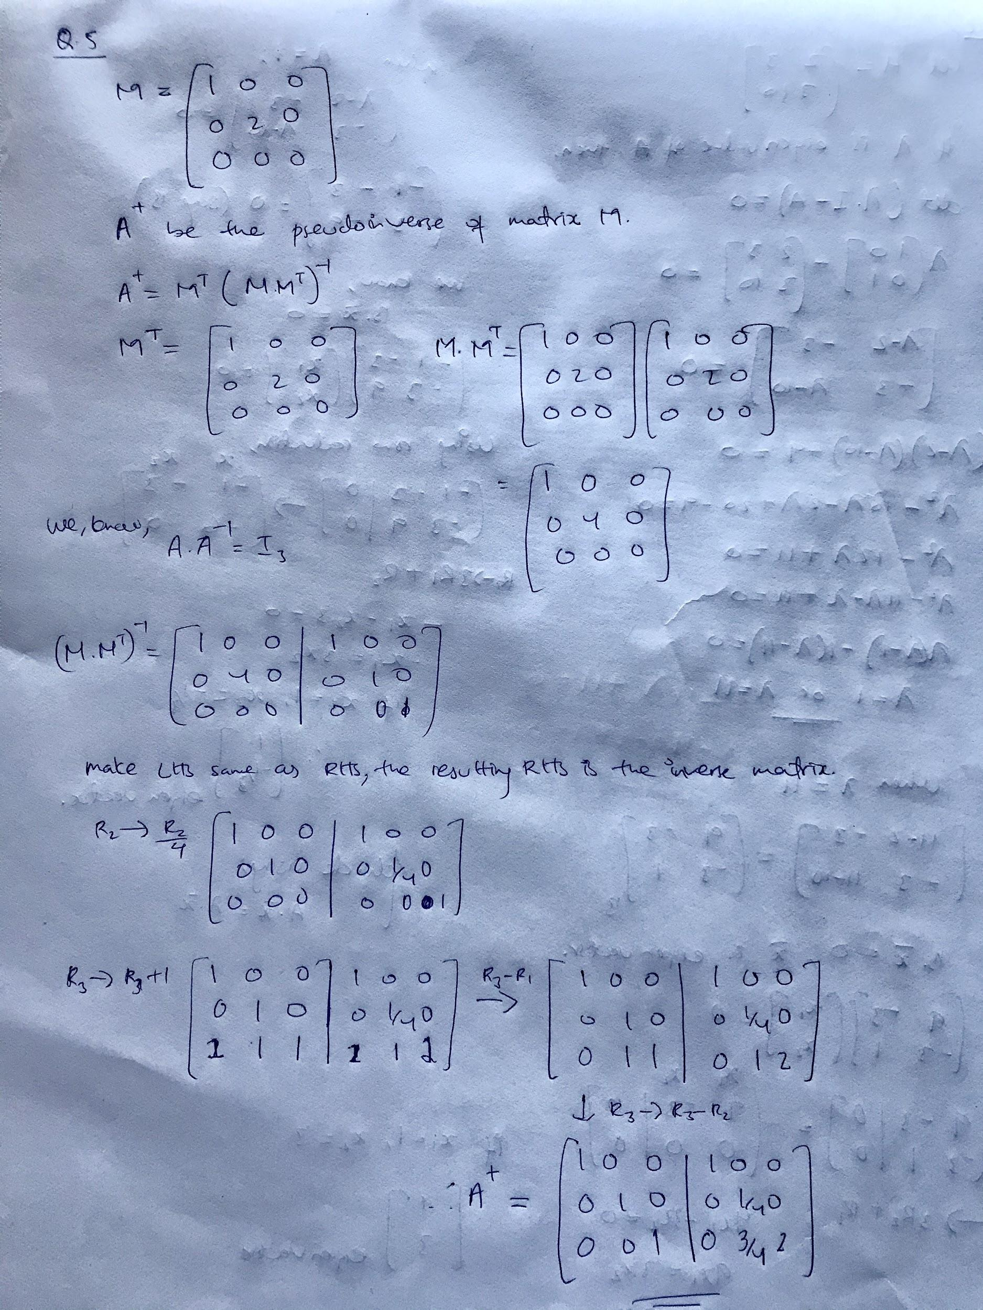

**Question 6**: When we perform a CUR decomposition of a matrix, we select rows and columns by using a particular probability distribution for the rows and another for the columns. Here is a matrix that we wish to decompose:

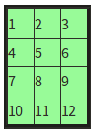

Calculate the probability distribution for the rows.

Ans.

